**Date Picker Automation Using Protractor**

In this document I am going to illustrate various automation techniques to automate the date picker in Angular applications. I will be sharing 5 different ways for 5 different scenarios.

1. Input dates using sendKeys().
2. Input dates for current date.
3. Input dates for current month.
4. Input dates for next/previous month/year.
5. Input dates for any month and year.

Description:

1. **Input dates using sendKeys()**

As we know protractor gives us a simple way to send dates into an input field using sendKeys(). Method. For that we just need to grab the input element and then using sendKeys() method will do the work. For example, we need to send just a date to a date picker. The test scenario is like we need to save a record with a random date. The date could be any date. In this case using sendKeys() method is very convenient.

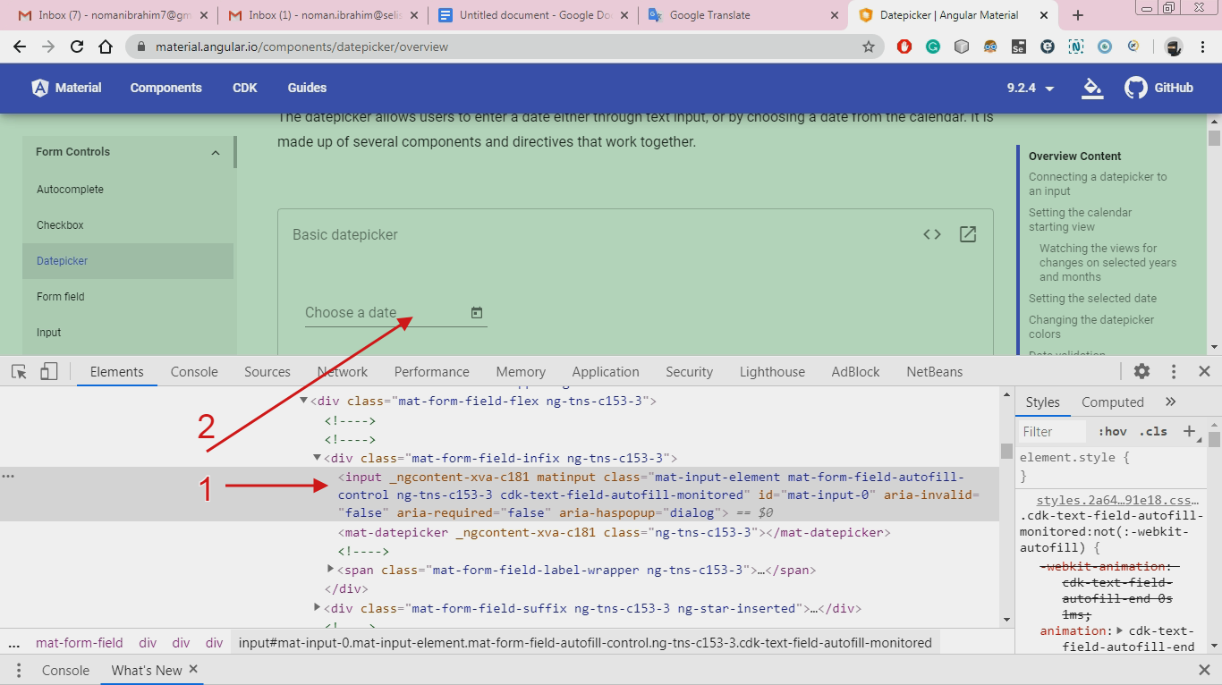

For this we just need to grab the input element by id, which is “**mat-input-0**”. On this element we can call the send keys method. We need to keep in mind sometimes the id can be dynamic and change every time the page gets loaded. In that case we need to apply a different approach to grab the input element.

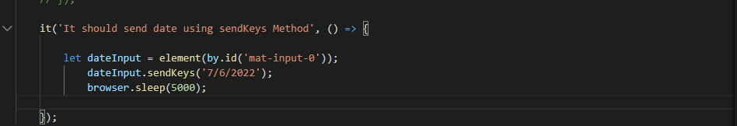

1. **Input dates for current date.**

Let's consider a scenario where we need to generate a report. And the report only generates according to the current date. Every time we want to generate the report we need to provide a current date. For that scenario simple sendKeys() with a manual static date won't be any good. So we need a Javascript function which helps us to generate a current date from the system whenever we call that function.

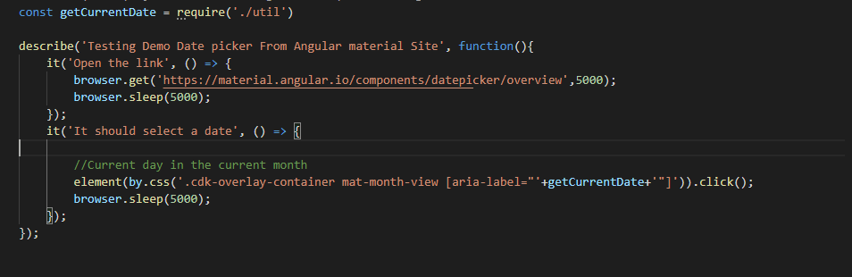

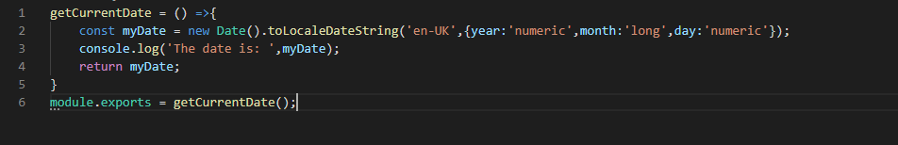

1. **Input dates for current month.**

Sometimes we can be encountered with a scenario where input element for date is disable like the following example.

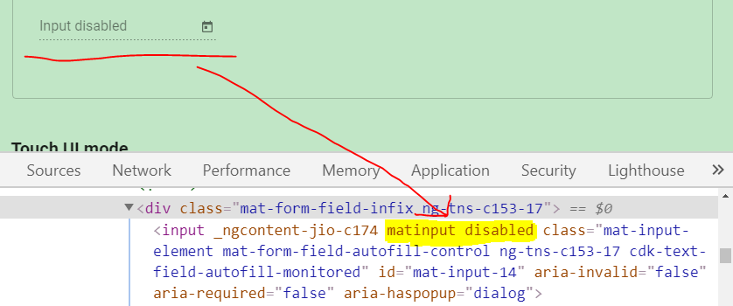

In that case we can not perform sendKeys() method on this input field. So we need to walk through with a new approach. In that case we need to find the date picker element icon in the DOM, click on that. Then a calendar will open. We can just then provide the date by following.

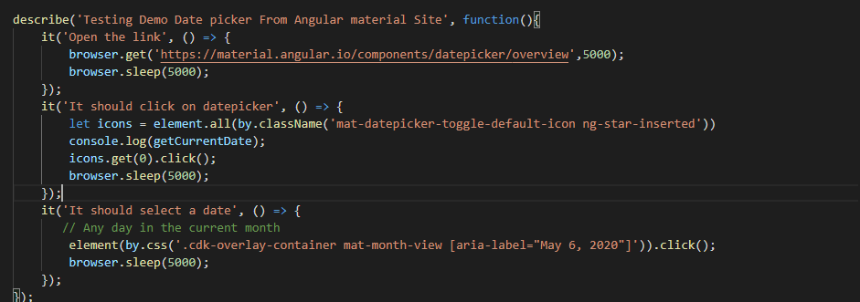

Grab the aria-label attribute.



1. **Input dates for next or previous month.**

What if we want a date from next month/previous month/next year/previous year. Look at the following image.

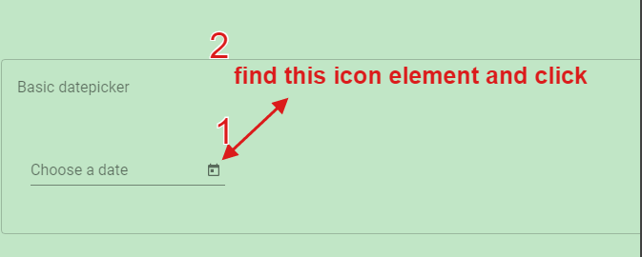

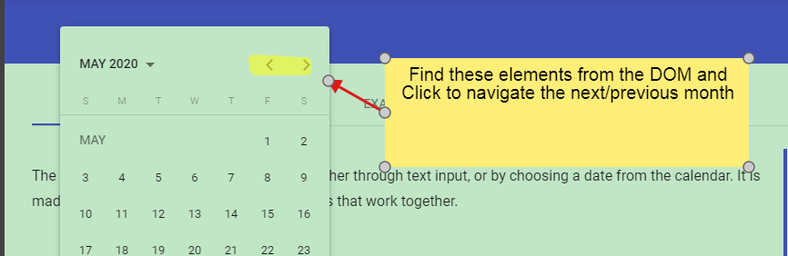

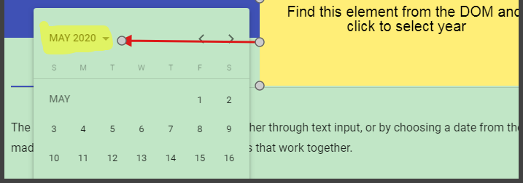

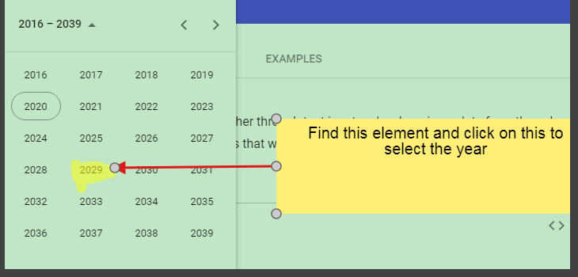

The code for this:

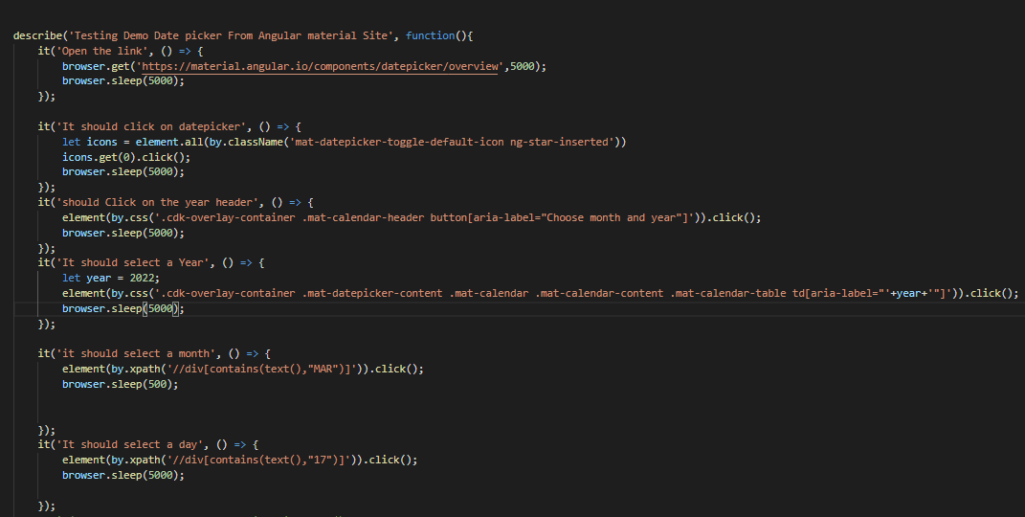

1. **Input dates for any month and year.**

I have created a method where we can input the elements and the date we need to select. The method will dynamically find that date for me. This method can be upgraded more for more convenient and easy use. I am working on it.

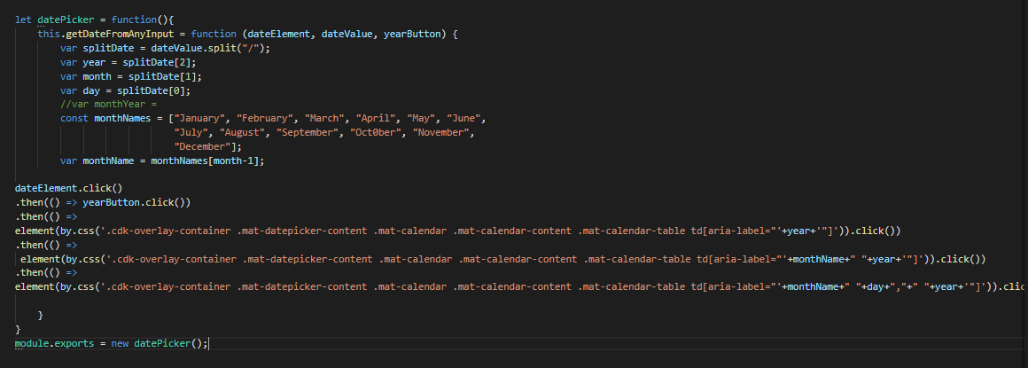

There is another way to put the date. That is to execute JavaScript. Like the following.



But I found it not stable and convenient to use.

I have tested my code on the following website.

[Material.angular.io](https://material.angular.io/components/datepicker/overview)

You can find the code in my github repo. The link is:

<https://github.com/Noman46/Protractor_Practice/tree/master/DatePicker>